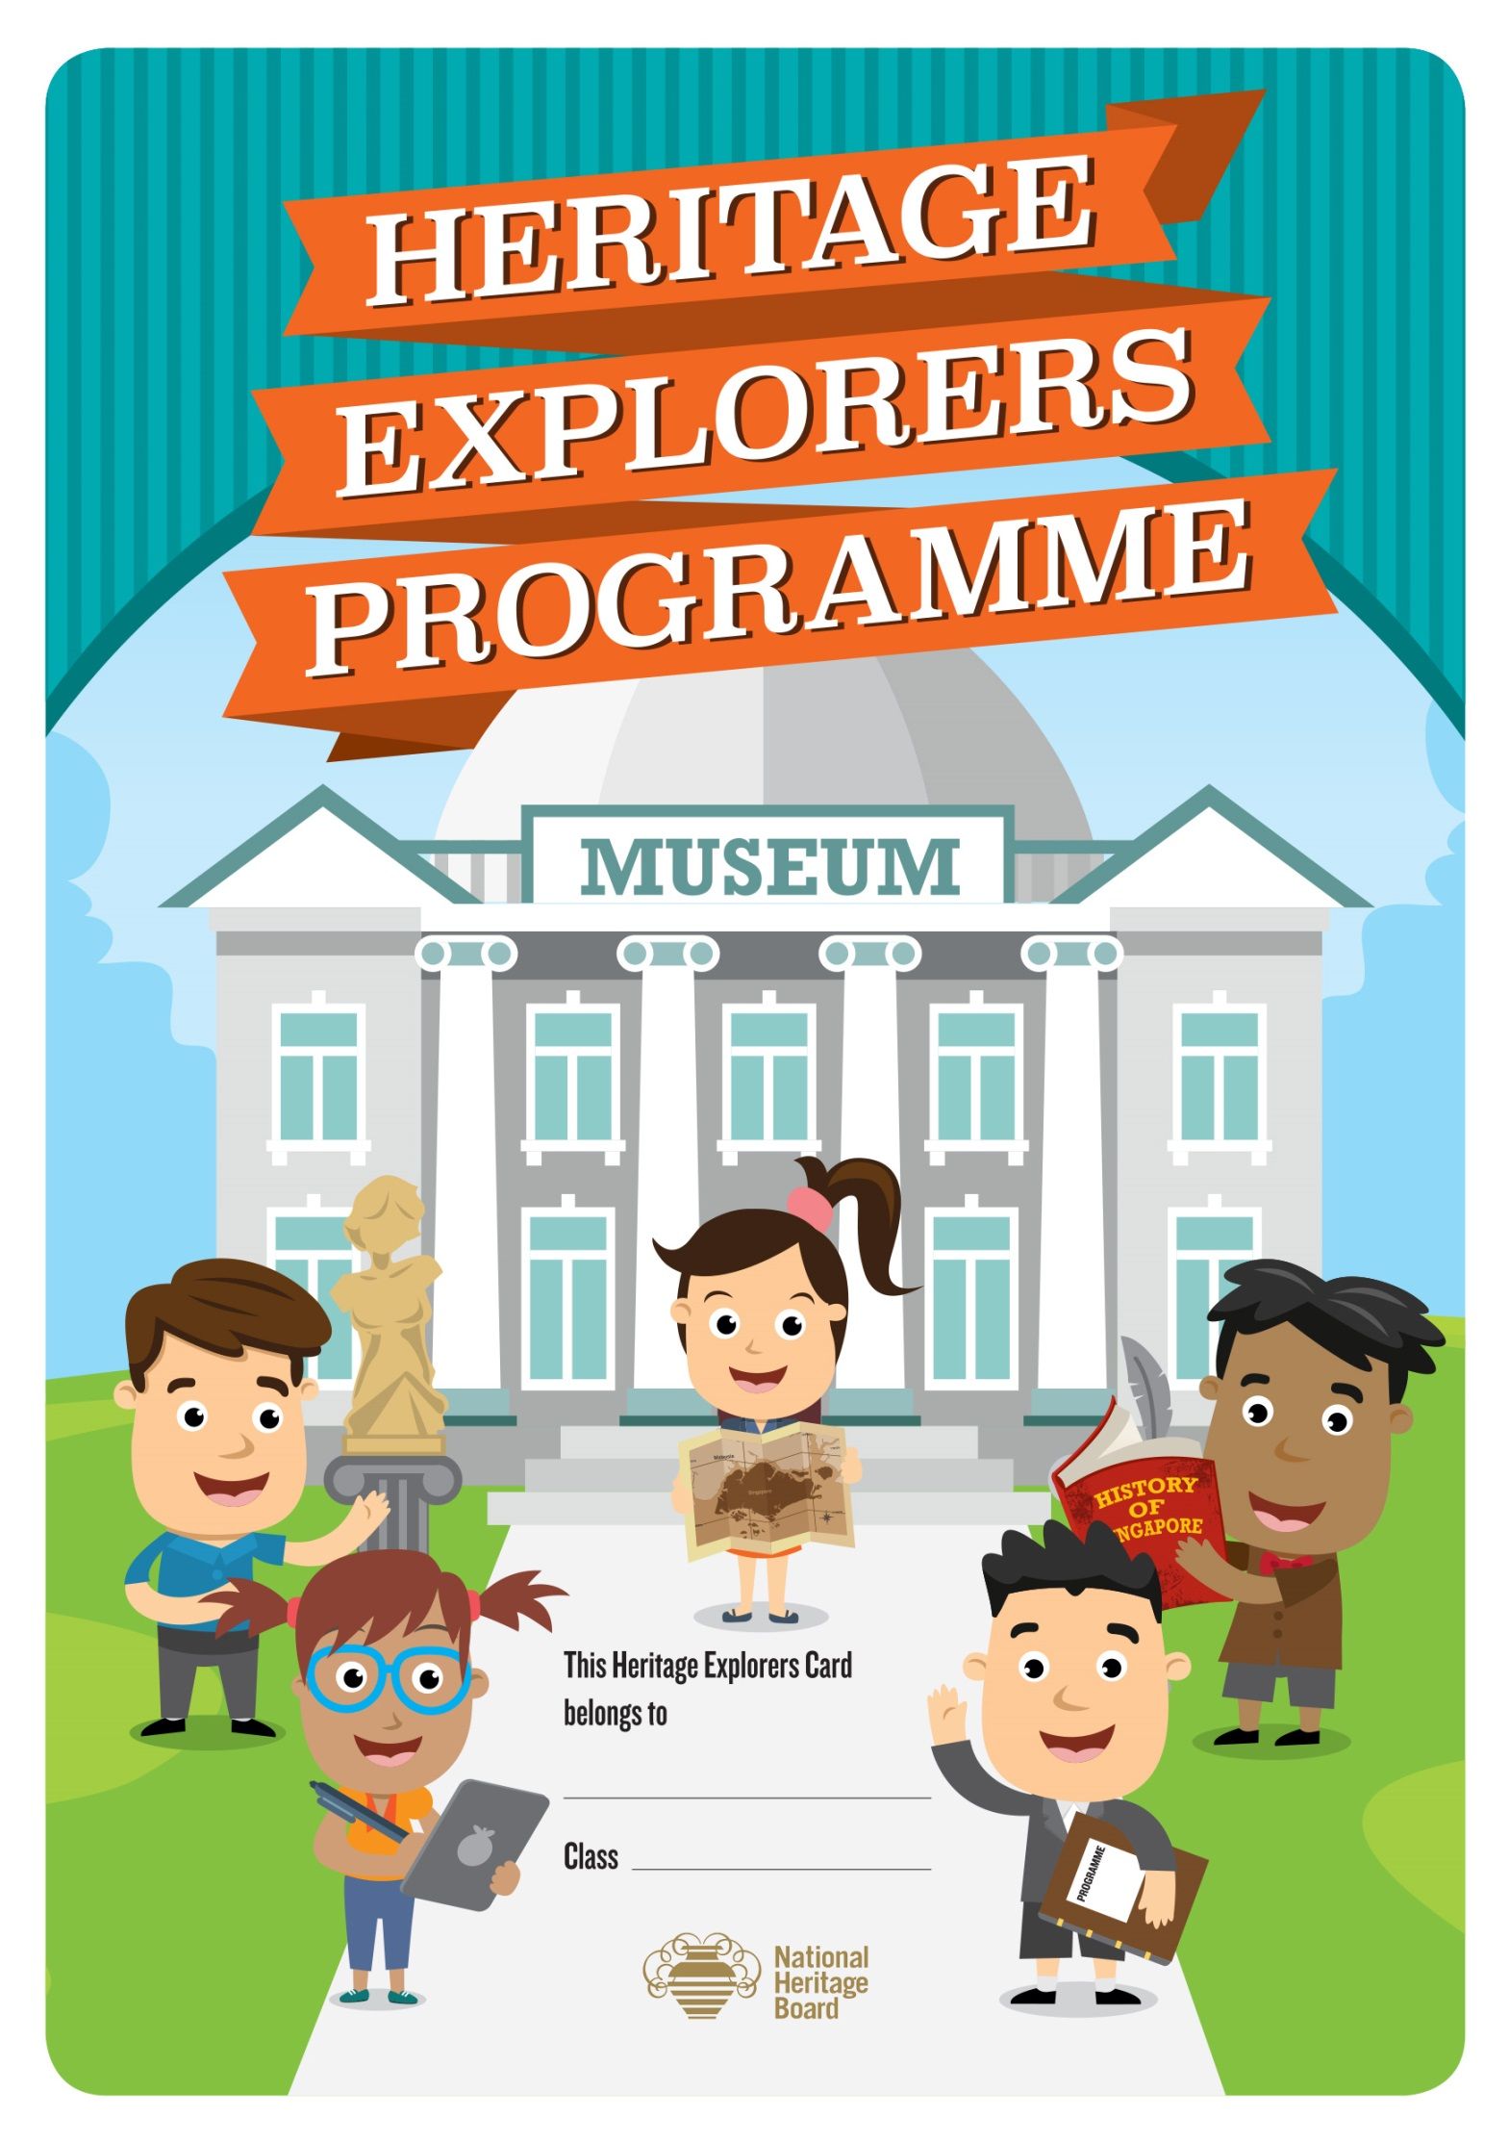

Educators’ Guide
As of 8 November 2016

Heritage Explorers Programme: Educators’ Guide

Contents

a. Overview

b. Objectives

c. About the Programme

d. Museum Etiquette

e. Museum Locations

f. Resources

g. Templates

h. Annexes 1 - 4

a. Overview
The Heritage Explorers Programme aims to raise students’ awareness and interest in local and community heritage, with the greater goal of enabling them to become informed, active and concerned citizens. Students will be tasked to complete a variety of heritage-related activities, exploring topics that can range from personal family histories to community and national history; from elements of tangible heritage (e.g. built heritage) to intangible heritage (e.g. local culture, traditions and beliefs). To encourage school-parent partnership and greater parent-child bonding, some parent-child activities will also be included. Students will present the completed tasks to their teacher/parents/guardians to verify the completion of tasks, and upon completion, students will be awarded with a Heritage Explorers Badge. In this manner, the Heritage Explorers Programme encourages self-directed and proactive learning, and helps to cultivate a sense of commitment to and passion for heritage.

b. Objectives of Programme
The Heritage Explorer Programme aims to:
- Develop character and values in students through heritage education
- Impart social awareness and skills to enable students to become informed, active and concerned citizens
- Stir interest in heritage, culture and to build a sense of national identity from a young age
- Encourage self-directed and proactive learning

c. About the Programme

What is the Heritage Explorers programme about?
The Heritage Explorers Programme consists of 5 heritage professions that the students can choose from and attain the badge(s). The Heritage Explorers badges are awarded to those who have the passion, commitment and drive to learn about, research and share their knowledge of matters related to Singapore’s history, culture and beliefs.
Below are some examples of heritage professions:
What does it mean to be a…
- Curator: A curator is responsible for exhibitions or collections within a museum. He/she chooses which artefacts to be placed on display and conducts research on the artefacts. He/she plays an important role in giving meaning to the artefacts, making connections to our heritage and presenting them in a story for visitors to understand our heritage better.

- Designer: A designer creates designs to showcase unique memories and objects to honour our heritage.

- Historian: A historian is someone who has a strong interest in past events. He/she conduct detailed research on historic events and turn it into informative articles. He/she plays an important role in creating links to our heritage to help people learn and understand our shared past and heritage.

- Educator: An educator is someone just like your teacher. He/she looks out for important information, knowledge and ideas. He/she plays an important role in sharing his/her knowledge with others and inspires them to learn more about things related to heritage.

- Ambassador: A heritage ambassador is someone who is passionate about heritage and constantly encourages others to participate actively in heritage-related programmes. He/she plays an important role in reaching out to individuals to learn and participate in heritage-related programmes.

Some of the tasks listed in the programme complement topics covered in Social Studies and Character and Citizenship Education syllabi. Annex 1 summarises the linkages to NE Messages, NE core events and the syllabi.
Introductory PowerPoint presentation slides are also available for download if you wish to go through with your students in class.

Who is eligible for the programme?
The programme is open to all primary school students.

How can I enrol the students into the programme?
The Heritage Explorers Programme will be open for application only 1 time a year.
Below is a breakdown of the programme schedule:
Submission of Application Form to NHB (Annex 2) | Distribution the booklets to schools | Closing date of submission of Badge Request form to NHB (Annex 3) | Distribution of badges to schools
Anytime from  9 January to 3 March 2017 | Within 2 weeks from the date of submission of application form | Latest by  15 September 2017* | By first 2 weeks of November 2017
* You may write in to request to obtain the badges earlier once the students have completed the projects.

Table 1: Key milestones of the Heritage Explorers Programme

All applications must reach us by the closing date. Late applications will not be accepted.

The Application and Badge Request Form can be found in Annex 2 and 3 respectively. Schools are to email the form to:

NHB.heritageexplorers@gmail.com and CC: nhb_educationprogrammes@nhb.gov.sg

Getting Started
The students will be provided with a Heritage Explorers Booklet for them to keep. This booklet is a tangible symbol of their participation in the Heritage Explorers Programme.

What must the students do to get the badge?
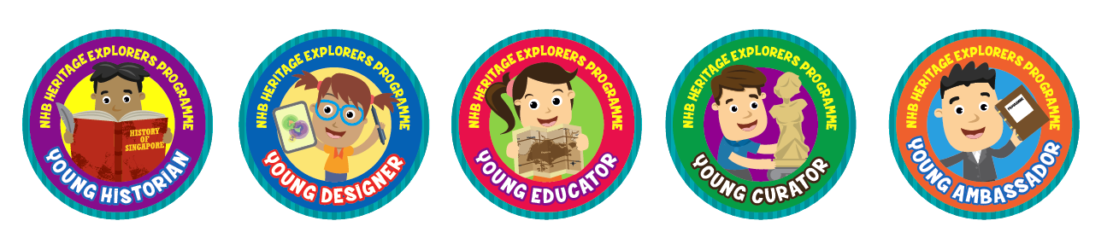
Heritage Explorers Badges
Students must decide on which profession(s) they would like to undertake and complete three out of five tasks from the selected profession to attain the badge(s) within 1 semester from the start date (refer to Table 1). Students are encouraged to complete the series of professions and collect all FIVE badges within their primary school years!
Students are to complete the tasks on A4 papers and compile them to form their own heritage collection. The word limit for each task is from 30 to 70 words. Students can refer to pages 9 -10 of their Heritage Explorer Booklet for useful information and links. Templates for some of the tasks can also be downloaded from http://www.nhb.gov.sg/education/resources-for-schools-and-students.

Award of the badge
Teachers-in-charge and/or parents/guardians will be responsible in ensuring that the students’ projects meet the required standards of the Heritage Explorers Programme. Parents are given the autonomy to certify one task and the teachers-in-charge will certify the remaining two tasks for each selected profession.
Upon completion of all three tasks, the student will complete the Reflection Page and Completion Card (Annex 4) and submit the Heritage Explorers Booklet to the teacher-in-charge for their records. Teachers may print additional copies of Completion Card if students have already used it in the previous rounds of submission. The Heritage Completion Card can also be downloaded from http://www.nhb.gov.sg/education/resources-for-schools-and-students. All Completion Cards must be submitted to NHB.
The school will also collate the number of students who are eligible for the badges, complete the Badge Request Form found in Annex 3 and submit to NHB before the stipulated dates indicated in Table 1. Teachers are encouraged to submit at least 10 outstanding projects per school to NHB.
We encourage schools to achieve a badge attainment target of 75% for the Heritage Explorers Programme.

d. Museum Etiquette
To enjoy the best museum experience, you can get the students to view a video on museum etiquette at https://www.youtube.com/watch?v=fHTPeEipNO0
You can also inform your students to observe the following:

How to maximise the benefit of a Museum tour?
- Listen attentively to the museum guide
- Ask questions on any aspect of the exhibitions and artefacts you wish to know more
- Closely observe the artefacts, paintings or works of art
- Take turns to explore the hands on corridors or activities which are available in some galleries

What do you do during individual/group work?
- Conduct oneself properly when on an independent tour or remain with the group at all times
- Work together quietly on your own projects
- Although some discussion in the galleries is encouraged, please keep the volume respectfully low. The Museum is a place for observing, thinking, and quiet discussion
- Use pencils instead of pen to write notes or create your sketches

What is considered proper conduct in the Museums?
- Be considerate to other visitors by keeping voices down
- Do not lean on glass panels and showcases, or use them to write answers on the worksheets. This may break the glass, tip the showcase or damage the artefacts
- Help us preserve the artefacts and artwork by not touching them, unless otherwise stated
- Eating or drinking in the gallery is not permitted
- Flash photography inside the galleries is not allowed. The flash from the camera might cause harm to the artefacts, especially vulnerable materials made of paper as they may fade. Accumulated exposure to strong lighting, like flash light can cause coloured pigments to fade. Please note that the copyright issues have to be taken into consideration even if photography is allowed in the galleries

e. Museum Locations
For detailed information, please visit the museum’s website.
Museum | Address and Website URL | Opening Hours
Asian Civilisations Museum | 1 Empress Place,  Singapore 179555  https://www.acm.org.sg | Daily: 10am - 7pm  Fridays: 10am - 9pm
Indian Heritage Centre | 5 Campbell Lane,  Singapore 209924  http://www.indianheritage.org.sg/ | Tuesdays - Thursdays: 10am - 7pm  Fridays – Saturdays: 10am - 8pm  Sundays/Public Holidays: 10am - 4pm  Closed on Mondays
Malay Heritage Centre | 85 Sultan Gate,  Singapore 198501  www.malayheritage.org.sg | Tuesdays - Sundays: 10am - 6pm  Closed on Mondays
National Museum of Singapore | 93 Stamford Road,  Singapore 178897  www.nationalmuseum.sg | Daily: 10am - 6pm
Singapore Philatelic Museum | 23-B Coleman Street,  Singapore 179807  https://www.spm.org.sg/ | Mondays: 1pm - 7pm  Tuesdays - Sundays: 9.30am -7pm
Sun Yat Sen Nanyang Memorial Hall | 12 Tai Gin Road,  Singapore 327874  www.sysnmh.org.sg/ | Tuesdays - Sundays: 10am - 5pm  Closed on Mondays
The Peranakan Museum | 39 Armenian Street,  Singapore 179941  https://www.peranakanmuseum.sg | Daily: 10am - 7pm  Fridays: 10am - 9pm

Resources
Festivals | NHB Heritage Trail | Sites and Monuments
Chinese New Year  Mid Autumn Festival  Hari Raya Puasa  Hari Raya Haji  Deepavali  Thaipusam  Good Friday  Christmas | Toa Payoh Trail  Jalan Besar Trail  Tiong Bahru Trail  *Kampong Glam Trail  **Yishun Sembawang Trail  Ang Mo Kio Trail  *Balestier Trail  *World War II Trail  Civic District Trail  Resilience Trail  Singapore River Trail  Chinatown Trail  Fort Canning Trail  Queenstown Trail  Jurong Trail  */**Jubilee Walk  *Mobile app available  ** worksheets for students available  All the heritage trail booklets can be downloaded from the link below. | Old Macdonald House  Central Fire Station  Victoria Theatre and Concert Hall  (Refer to the website below for the full list)
Family Time Activity Sheets:
http://www.nhb.gov.sg/education/resources-for-families
Information on NHB Heritage Trails:
http://www.nhb.gov.sg/places/trails/overview
Information on Sites and Monuments:
http://www.nhb.gov.sg/psm
Other useful links:
Videos on Heritage
Search Heritage TV on Youtube
Infopedia
http://eresources.nlb.gov.sg/infopedia/
To read up about Singapore’s festivals:
http://www.yoursingapore.com/content/traveller/en/browse/see-and-do/culture-and-heritage/cultural-festivals.html
To read up about other Singapore’s well remembered places that Singaporeans will enjoy: http://www.iremember.sg/
To read up about memories from other Singaporeans about life in the past: http://www.singaporememory.sg/

g. Templates
Teachers are encouraged to print the templates and pin it up on the class notice board.
Family Crest Template (Heritage Explorers - Designer)

Tote Bag Template (Heritage Explorers – Designer)

Post Card Template (Heritage Explorers - Educator)
(front)

(back)

Alignment to Character and Citizenship Education & Social Studies Syllabi, NE Messages and Core Events
Annex 1
CURATOR

Task |  | Social Studies Books/Activities/Field Trips | Character and Citizenship Education EL textbooks | NE messages/Core Events
- My family and I | Draw and share one happy memory you have of your family.  Write 5 things of your drawing you can do to make your family happy. | - P1 SS story book: Don’t cross the line | - P2 Pg 46 : Family Time: Uniquely me : Self-Respect  - P3 Pg 16: Caring for Family Members  - P3 87: Caring for Others  - P5 Pg 63: Caring for Family Members
- My Vintage Collection | Draw/find/take 2 pic of any 2 objects from the past.  Find out more about them from your parents/guardians/grandparents/older siblings. | - P1 SS story book: Questions  - P1 FBL: Peranakan Museum  - P1 SS FBL Activity: design a T-shirt using motifs learnt  - P1 SS FBL Activity: match model to antique household items |  | NE msg#1: Singapore is our homeland; this is where we belong.  We treasure our heritage and take pride in shaping our own unique way of life
- A Taste of Harmony | Talk to any 2 friends of other races. Get each of them to share more about a dish that best represents their culture. Why did they choose these dishes? Find out more. Draw/find/take pictures of the 2 dishes and describe them. Or  Have a meal with your family and take a picture of yourself trying 2 dishes from a different ethnic group. Describe the dishes and explain why you chose them. | - P4A SS Activity : Food Galore (Pg 11-13)  - P5: Chap 4 & 6: Food during Ancient Civilisation  - 5B Textbook Pg 24-27, 78,79, 85-87  - P5B SS Activity book WB Pg 10  - P6B Textbook Pg Ch 5: Celebrating Common Traditions (Pg 43-52)  - P6B Activity book: Pg 11 Delicious Delicacies | - P1 Pg 12: Diversity in food and respect to classmates of other races and cultures.  - P1 Pg 90: Festivals/Celebrations and Respect for People of other Races and Cultures.  - P2 Pg 73: Harmony in the Community through Food/Festivals  - P2 Pg 89 : Diversity in food  - P3 Pg 62: Diversity in food | Racial Harmony Day : July  NE msg #2: We must preserve racial and religious harmony.  We value our diversity and are determined to stay a united people.
- I Love My Neighbourhood | Your school is planning to build a Heritage Corner to showcase the school’s and neighbourhood’s stories. What is one story about your neighbourhood that you would like to share? | - P1 SS story book : Questions  - Activity book Pg 16: My Neighbourhood  - P1 SS story book: Siti’s New Home  - Act book (Pg 4,5): My Friends and I  - P3 SS story book: Mr HDB; Who cares about one old tree?  - P3 SS Activity book Pg 11-12: How we live; Pg 22: I love this park! | - P3 Pg 60: Places in the neighbourhood : common spaces, eateries | NE msg#1: Singapore is our homeland; this is where we belong.  We treasure our heritage and take pride in shaping our own unique way of life
- My Favourite Thing | Together with your family or school, visit any museum and draw/take pic of 2 objects that you like most. | - P1 Field trip: Peranakan Museum  - P2 Field Trip: Singapore Philatelic Museum  - P4 : National Museum of Singapore  - P5 & P6: Asian Civilisations Museum | - P1 Pg 96 : Family time: Growing up in Singapore : Visit to National Museum of Singapore, Sense of belonging in Singapore, instil a love for Singapore, Childhood memories | NE msg#1: Singapore is our homeland; this is where we belong.  We treasure our heritage and take pride in shaping our own unique way of life

DESIGNER
Task |  | Social Studies Books/Activities/Field Trips | Character and Citizenship Education EL textbooks | NE messages/Core Events
- Family Identity | What makes you family special?  Design a logo to represent your family’s identity. | - P1 SS story book: Don’t cross the line
- Racial Harmony Poster | Create a poster to encourage harmony between people of different ethnicity. | - P2 SS story book : New Girl in Town  - P2 SS story book: Show Some Respect  - Activity book (Pg4-7): Match Ethnic Costume, Name Festival  - SS P4B Textbook Chap 8 Pg 79-97): Coming together as One Country  - 4B Activity book Pg 27: Racial Harmony and Me  - SS P5B TB Pg 81: How to Tie A Sari.  - SS P6B TB Chap 5 Pg 43-52: Celebrating Common Traditions  - P6B Activity book Pg 10: Festival of South East Asia | - P1 Pg 90 : Festivals/Celebrations and respect for people of other races and cultures  - P3 Pg 47 : Friendships/respect beyond race and nationalities  - P4 Pg 49: Value harmony and respect the various religious practices in Singapore. | - Racial Harmony Day : July  - International Friendship Day : April  NE msg #2: We must preserve racial and religious harmony.  We value our diversity and are determined to stay a united people.
- Bag Design | What do you think is unique about Singapore? Find pictures of one icon that best represents Singapore. Based on your chosen icon, design your own tote bag. | - P2 SS story book: We are Singapore  - Activity book Pg 14 Symbols ; Pg 21 Make a cube box  - P4 SS 4B TB Chap 6 Pg 35-45: Building Singapore’s Identity |  | National Day celebration : August  NE msg#1: Singapore is our homeland; this is where we belong.  We treasure our heritage and take pride in shaping our own unique way of life
- My Playground | Your school is planning to design a play area within the school compound. Design a play area suitable for your peers that would encourage the learning of different cultures. | - P1 SS story book : Siti’s New Home  - Activity book Pg 4,5 : My Friends and I  - P2 SS story book: Things so Singaporean  - Activity book Pg 9,10: My country, My Home |  | NE msg#1: Singapore is our homeland; this is where we belong.  We treasure our heritage and take pride in shaping our own unique way of life
- Museum Souvenirs | Visit any museum and take pictures of the objects that you like the most.  Design 2 museum souvenirs based on or inspired by the pictures you have taken. | - P1 Field trip : Peranakan Museum  - P2 Field Trip : Singapore Philatelic Museum  - P4 : National Museum of Singapore  - P5 & P6: Asian Civilisations Museum | P1 : Pg 96 : Family time: Growing up in Singapore : Visit to National Museum, sense of Belonging in Singapore, Instil a love for Singapore, Childhood memories | NE msg#1: Singapore is our homeland; this is where we belong.  We treasure our heritage and take pride in shaping our own unique way of life

HISTORIAN
Task |  | Social Studies Books/Activities/Field Trips | Character and Citizenship Education EL textbooks | NE messages/Core Events
- My Heritage | What is important to your family? Have a conversation with your parents/guardians/grandparents and identify one object that is precious to your family. Write a short story/poem/song based on or inspired by the object.
- Past Vs Present | What do your older family members remember about their neighbours and neighbourhood? Talk to them and find out: Where did they first live? Who were their neighbours? How were the neighbours similar or different from their neighbours today? What did they like about their old neighbourhood? | P1 SS story book: Questions
- Once Upon a Time | Take a look around your neighbourhood and imagine how it was like in the past. Draw/find pictures of your neighbourhood. | - P1 SS story book : Questions  - Act book Pg 16: My Neighbourhood  - P1 SS story book: Siti’s New Home  - Activity book Pg 4, 5: My Friends and I  - P3 SS story book: Mr HDB  - Activity book Pg 14: How many families can live here? | - P5 Pg 30: Neighbourhood : Past & Present  - P5 Pg 55: Family Time : Playground Mission – A walk down memory lane, caring for neighbours | NE msg#1: Singapore is our homeland; this is where we belong.  We treasure our heritage and take pride in shaping our own unique way of life
- Traditional occupations | Choose any 2 occupations and draw/find pictures of them. For each occupation, find out: What did they do for a living? What are the values they must have to do their jobs well? How have their jobs changed over time? | - P3 SS story book: Ah Kong’s Farm  - Activity book Pg 9 -12: To farm or not to farm?  - P4A Text Book Pg 35: Early CL labourers  - P4A SS Activity book Pg 14-16: Their jobs and qualities |  | NE msg#1: Singapore is our homeland; this is where we belong.  We treasure our heritage and take pride in shaping our own unique way of life
- Sites & Monuments | Together with your family, visit a historical site in Singapore. Draw/ take pictures of the site. What have you and your family learnt from this trip? Pen down your thoughts. | - P4 SS 4B Text book Chap 5 Pg1 - 34: Journey towards independence  - P4 : Civic District FBL | P4 Pg 55: Family Time : Remembering the Past, about Nation-Building, learn more about national monuments. | Total Defence Day : February  NE msg#5: We must ourselves defend Singapore.  We are proud to defend Singapore ourselves; no one else is responsible for our security and well-being.

EDUCATOR

Task |  | Social Studies Books/Activities/Field Trips | Character and Citizenship Education EL textbooks | NE messages/Core Events
- Let’s Play | Have you played any traditional games before? Choose one traditional game and create a simple instruction sheet on how to play the game or record yourself teaching a friend on how to play the game. | P6 SS topic Pg 67-70: Our Traditional Games | P2 Pg 81: Traditional games | Racial Harmony Day : July  NE msg #2: We must preserve racial and religious harmony.  We value our diversity and are determined to stay a united people.
- Know your Neighbour | Together with your family members, take picture with a neighbour from a different ethnic group. Have a conversation with them and find out how these are different from yours. | - P1 SS story book: Siti’s New Home  - Activity book Pg 4,5: My Friends and I  - P2 SS story book : New Girl in Town  - Activity book Pg 4-7: Match Ethnic costume, Name festival  - P2 SS story book: Show  - Some Respect  - P4A TB Chap 2 Pg 21-42: The Early Settlers | - P1 Pg 15: Diversity in food and respecting classmates of other races & cultures  - P1 Pg 78: Family Time: Good Neighbour – Forming good relationships amongst neighbours such as through positive body languages  - P2 Pg 73: Harmony in the community through food/festivals  - P3 Pg 47: Friendships/respect beyond race and nationalities  - P3 Pg 57: understanding and respecting different races & understanding your neighbours  - P6 Pg 49: Harmony in the community through food festivals | Racial Harmony Day : July  International Friendship Day : April  NE msg #2: We must preserve racial and religious harmony.  We value our diversity and are determined to stay a united people.
- Festivals in Singapore | Do you know all the festivals that are celebrated in Singapore? Select any 2 festivals that you do not celebrate. Draw/find pictures describe the 2 festivals you have selected.  Or  Find an opportunity to be part of one of the festivals that you do not celebrate. Take some pictures and describe what you did, observed and what you enjoyed most. | - P2 SS story book : New Girl in Town  - Activity book Pg 4-7: Match Ethnic Costume, Name Festival  - SS P5B Chap 4 & 6 Pg 24-27, 78,79, 85-87: Festival since Ancient civilisation  - Act WB Pg 13: Festival Time  - P6B TB Chap 5 Pg 43-52 Celebrating common traditions  - P6B Act book Pg 10: Festival of Southeast Asia | - P1 Pg 90 : Festivals/Celebrations and respect for people of other races and cultures  - P2 Pg 73: Harmony in the community through food/festivals  - P3 Pg 47: Friendships/respect beyond race and nationalities  - P4 P49: Value harmony and respect the various religious practices in Singapore  - P5 Pg 73: Friendships/respect beyond race and nationalities | Racial Harmony Day : July  NE msg #2: We must preserve racial and religious harmony.  We value our diversity and are determined to stay a united people.
- National Symbols | Do you know what Singapore’s national symbols are? Draw/take pictures of any 2 national symbols. Find out the meaning behind them. | - P2 SS story book : We are Singapore  - Activity: Pg 14 paste sticker of Symbols, Pg 21 Make a cube box  - SS 4B TB: Chap 6 Pg 35-48 : Building Singapore’s Identity  - P4B SS activity Pg 13: The National Crest | - P1 Pg 96 : Family time: Growing up in Singapore : Visit to National Museum of Singapore, Sense of belonging in Singapore, instil love for Singapore, Childhood memories | National Day celebration : August  NE msg#1: Singapore is our homeland; this is where we belong.  We treasure our heritage and take pride in shaping our own unique way of life
- Heritage Hunt | Together with your family, visit a cultural area or any heritage institutions. Draw/Take pictures of the most memorable moment of your visit. Create a postcard and share your family’s adventure with a friend. | P4 : Field-trips to heritage sites or other school Heritage Tours programme | P3 Pg 60: Places in the neighbourhood : common spaces, eateries | NE msg#1: Singapore is our homeland; this is where we belong.  We treasure our heritage and take pride in shaping our own unique way of life

AMBASSADOR

Task |  | Social Studies Books/Activities/Field Trips | Character and Citizenship Education EL textbooks | NE messages/Core Events
- Places They Used To Go | Where do you think people go to for leisure in the past? Get parent/guardians/grandparents to share their memories on 2 places in Singapore where their parents used to bring them and record their memories. If the places are still around, get your parents to bring you there and take a picture. | - P2 SS story book: Things so Singaporean  - Activity book Pg9,10: My country, My Home | - P3 Pg 60: Places in the neighbourhood : common spaces, eateries  - P5 Pg 55: Family Time : Playground Mission – A walk down memory lane, caring for neighbours | NE msg#1: Singapore is our homeland; this is where we belong.  We treasure our heritage and take pride in shaping our own unique way of life
- I Love My School | How well do you know your school? Give a guided tour to at least 2 friends/family members to your school’s heritage corner or favourite places in schools. Explain the reasons for selecting these places. Prepare a script or record yourself in action. | Schools’ heritage corners |  | NE msg#1: Singapore is our homeland; this is where we belong.  We treasure our heritage and take pride in shaping our own unique way of life
- Family Time (Heritage Trail) | Bring your family on a heritage trail and take a family photo at two locations which you think best represent the country’s heritage. Write down what you and your family have learnt from the 2 locations and present it in the most creative way. | - P1 Field trip: Peranakan Museum  - P2 Field Trip: Singapore Philatelic Museum  - P4 : National Museum of Singapore  - P5 & P6: Asian Civilisations Museum | P3 Pg 69: Heritage trail: find out more on roads and landmarks | NE msg#1: Singapore is our homeland; this is where we belong.  We treasure our heritage and take pride in shaping our own unique way of life
- Museum Expert | Together with your family, visit a museum and choose 2 objects you like most. Present the 2 objects to your family members and record a video of yourself in action. | - P1 Field trip: Peranakan Museum  - P2 Field Trip: Singapore Philatelic Museum  - P4 : National Museum of Singapore  - P5 & P6: Asian Civilisations Museum | P1 Pg 96: Family time: Growing up in Singapore : Visit to National Museum of Singapore, Sense of belonging in Singapore, instil a love for Singapore, Childhood memories | NE msg#1: Singapore is our homeland; this is where we belong.  We treasure our heritage and take pride in shaping our own unique way of life
- Family Time (Museum) | Explore the museum’s fascinating artefacts with family. Go on a guided tour, take family pictures at the location, upload on social media and complete any one worksheet. | - P1 Field trip: Peranakan Museum  - P2 Field Trip: Singapore Philatelic Museum  - P4 : National Museum of Singapore  - P5 & P6: Asian Civilisations Museum | P1 Pg 96: Family time: Growing up in Singapore : Visit to National Museum of Singapore, Sense of belonging in Singapore, instil a love for Singapore, Childhood memories | NE msg#1: Singapore is our homeland; this is where we belong.  We treasure our heritage and take pride in shaping our own unique way of life

Annex 2

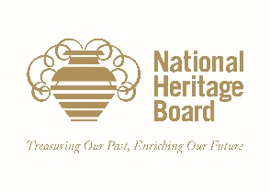
Please complete this application form and email it to:

NHB.heritageexplorers@gmail.com and CC nhb_educationprogrammes@nhb.gov.sg

NATIONAL HERITAGE BOARD
HERITAGE EXPLORERS PROGRAMME
APPLICATION FORM

I) SCHOOL PARTICULARS
Date of submission
Name of school
Address
Postal code
Total school enrolment
II) CONTACT PERSON FOR HERITAGE EXPLORERS PROGRAMME
Name
Designation
Contact No: | Tel: |  |  | HP:
Email Address:
III) HERITAGE EXPLORERS BOOKLET REQUEST
Number of booklets | P1 | P2 | P3 |  | P4 | P5 | P6
Total:
FOR OFFICIAL USE
Received by:

Date received:

Date of delivery of cards to school:

*please delete accordingly
This form is to be submitted to NHB between 9 January to 3 March 2017. Late submission will not be accepted.
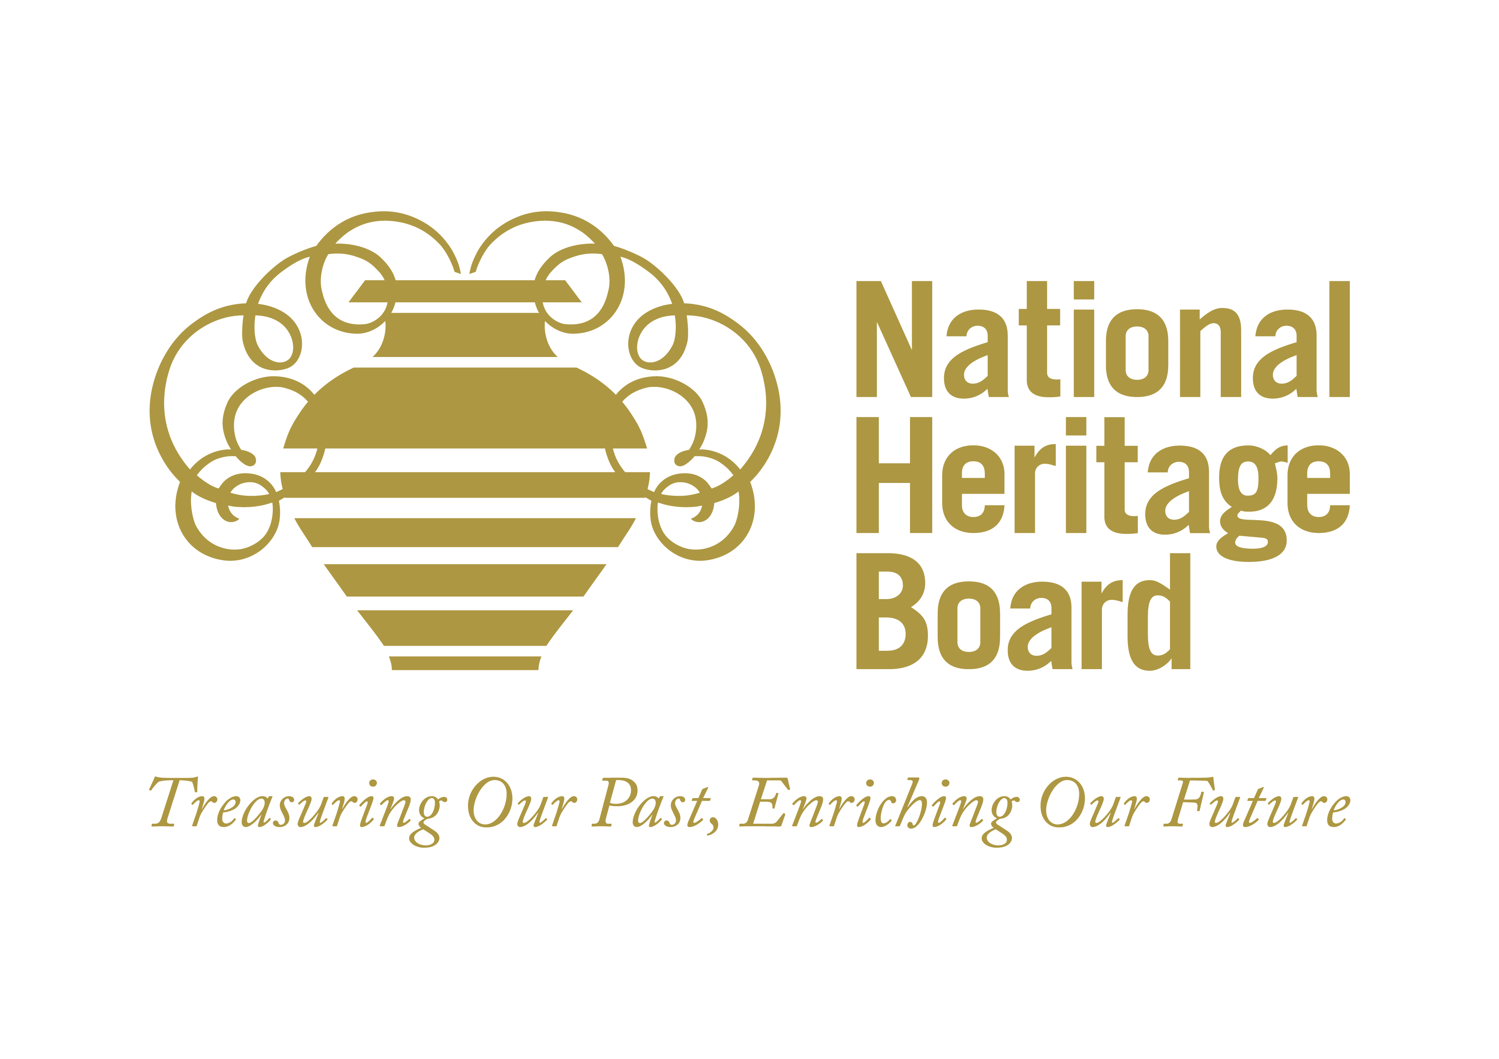
Annex 3

Please complete this form and email it to:

NHB.heritageexplorers@gmail.com and CC nhb_educationprogrammes@nhb.gov.sg

NATIONAL HERITAGE BOARD
HERITAGE EXPLORERS PROGRAMME
BADGE REQUEST FORM
I) SCHOOL PARTICULARS
Date of submission
Name of school
Address
Postal code
II) CONTACT PERSON FOR HERITAGE EXPLORERS PROGRAMME
Name
Designation
Contact No: | Tel: |  |  | HP:
Email Address:
III) BADGE REQUEST
Type of badge | Ambassador | Curator | Designer |  | Educator | Historian
Total number of badges
FOR OFFICIAL USE
Received by:

Date received:

Date of delivery of badges to school:

This form is to be submitted to NHB by 15 September 2017. Late submission will not be accepted.

Annex 4

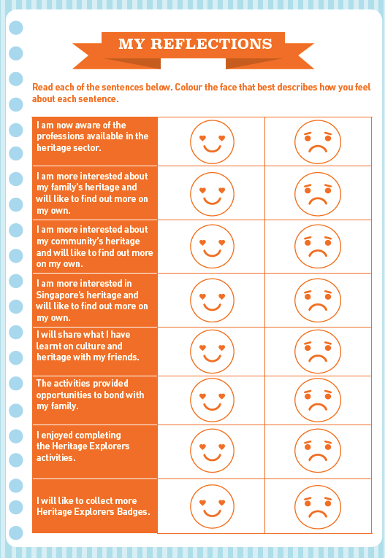

Annex 4
